|  |
| --- |
| JavaScript Framework |
| Billy Hofland  DB03  2023/2024 |



Research Report

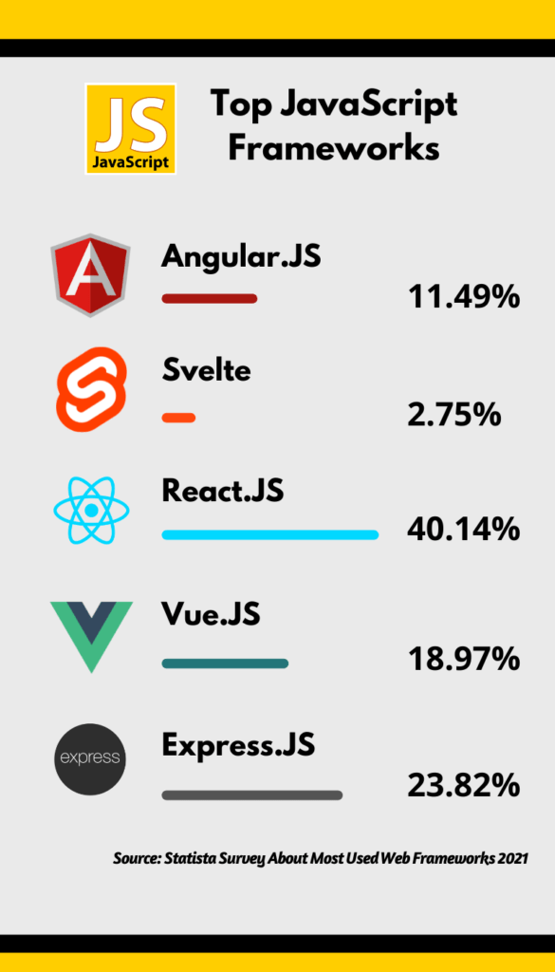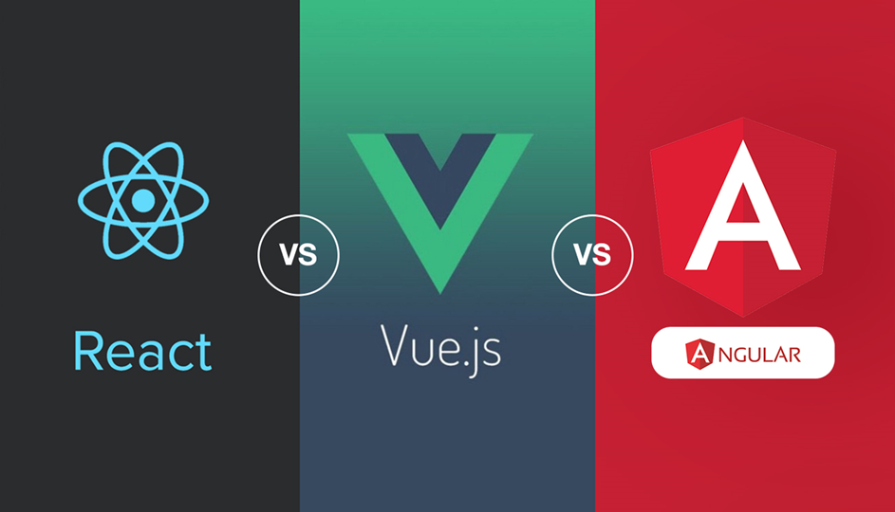

Table of contents

Introduction 3

Problem description 3

Main question: 3

Sub-questions: 3

Results 4

Sub-question 1: 4

Sub-question 2: 4

Sub-question 3: 4

Sub-question 4: 4

Resolution 5

Conclusion: 5

Recommendation: 5

References 6

Version history 7

# Introduction

## Problem description

JavaScript frameworks are essential in the construction of web applications. They provide developers with structured ways to build applications by offering code snippets, functions, and modules that you can reuse and customize. There are a lot of JavaScript frameworks that offer different features specific for the needs of your project. Hence, it is important to analyze, compare and select the most suitable framework that aligns with the goals and needs of the project.   
  
Because of the rapidly evolving amount of JavaScript frameworks, it is a challenge for developers and companies to select the most appropriate one for their specific needs. The choice of a framework can impact the efficiency, maintainability, and performance of web applications.

## Main question:

Which JavaScript framework is most suitable for developing an online education platform?

## Sub-questions:

1. What are strengths and weaknesses for the most popular JavaScript frameworks?
2. Document analysis: By looking at the documentation, I can find information about strengths and weaknesses of the most popular frameworks.
3. SWOT analysis: By conducting a SWOT analysis for each framework, identify the strengths, weakness, opportunities, and threats.
4. How readily available and comprehensive are the support and resources, including documentation, community forums, and tutorials, for popular frameworks?

A. Community Research: By searching for various forums and user created posts, I can find out what community is the most active for popular frameworks.

B. Survey

1. What are the built-in security protections and vulnerabilities in popular frameworks?
2. Security tests: For the most popular frameworks, perform a security test, this can include tools and techniques to test the security of a popular framework.
3. Literature study: By researching online guides and forums, I can get a general idea of strengths and weaknesses of the most popular frameworks.
4. How easily can each framework be customized to meet the specific needs and features required for an online education platform?
5. Best good and bad practices: By viewing existing projects, I can see how developers managed to customize their needs and features with a specific framework.
6. Observation: By looking at what other people are using and how they are customizing their framework I can see if it’s a good fit for my project

# Results

## Sub-question 1:

## Sub-question 2:

## Sub-question 3:

## Sub-question 4:

# Resolution

## Conclusion:

## Recommendation:

# References

# Version history

|  |  |
| --- | --- |
| **When?** | **What?** |
| 21/09/2023 | Version 1.0 of research report |
| 28/09/2023 | DOT Framework for sub-questions |
|  |  |